JUNIT ASSIGNMENT

1)write a class called Min Max Finder. Define a method in it called find Min Max () which accepts an int array and returns new array of size 2, wherein the 0 index will have the min value of the array and 1 index will have max value of the array. perform Junit testing of the method find Min Max with as many test cases you can think of.

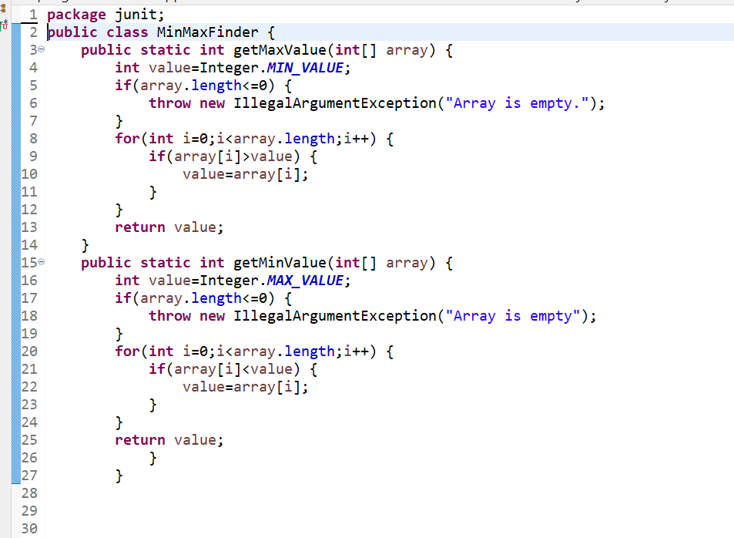

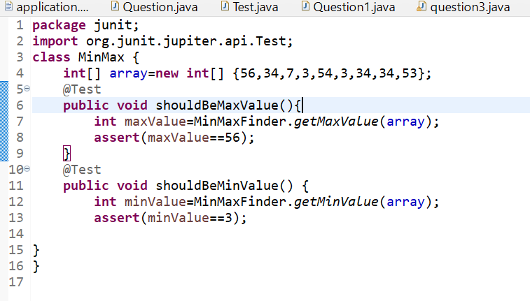

Output:

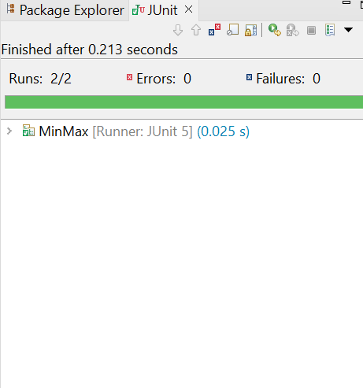

2)Write a Junit Testing to show the use of Lifecycle hooks annotation such as @BeforeAll,@BeforeEach,@AfterEach And @AfterAll.

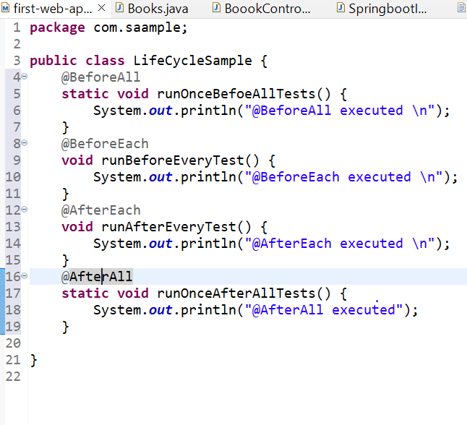

Output:

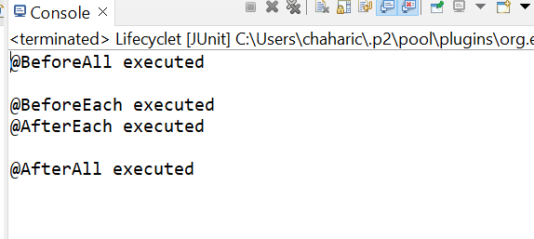

3)Write a Bank Account class with method withdraw which accepts amount to be withdrawn from the account. In case there are insufficient funds a insufficient Funds exception should be raised. After defining the method perform Junit testing to check whether the insufficient Funds Exception is raised when you try to withdraw amount that is over and above the account balance.

